East Bay Sailing Foundation
Parent Handbook 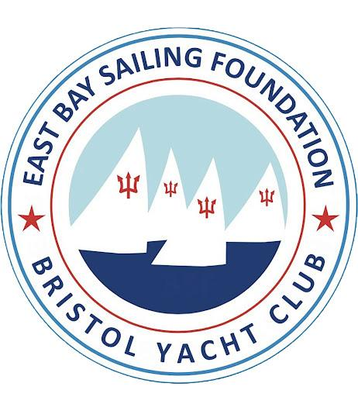
2023 Summer Season MISSION STATEMENT:
Our mission is to foster self-confidence through instruction in sailing, seamanship, and racing skills at appropriate levels in a safe and fun environment so that participants may enjoy the benefits of sailing for a lifetime. We encourage an ongoing dialogue among students, parents, instructors, the EBSF Committee and the involvement of anyone who supports these goals.
CONTACT INFORMATION:
Program Director: Trish Sellon
Email: programdirector@eastbaysailingfoundation.org
Office phone: (401) 257-6774
Cell phone: (401) 793-1358
Mailing Address: P.O. Box 855 Bristol, RI 02809
LOCATION:
East Bay Sailing Foundation operates out of Bristol Yacht Club located:
101 Poppasquash Road, Bristol, RI 02809
EBSF Board and Committee Chairs
Board Chair
Richard Feeny - richard.feeny@gmail.com
Governance
Bob Millard - rmillard1954@gmail.com
Vice Commodore of Bristol Yacht Club
Paul Redman - pwredman@gmail.com
Past Chair
Kristin Browne

Non-Member - Equipment Committe Chair
Brad Haverly

Finance Committee
Bob Elder - bob@egptax.com
Adult Sailing
Peter Maloney - PeteMaloney@gmail.com
ARRIVAL/DISMISSAL:

Arrival: Students may begin arriving 15 min before their class start time. Children under the age of 12 must be accompanied by a parent or guardian upon entering the grounds, Please park in the grass lot and assist your student(s) to their designated location on the main grass field. Verify that your child is checked in by their instructor. If your child is going to be late please notify the program director.

Dismissal: Students must check out with their instructor when getting picked up. Please notify the instructor if someone else other than parent/guardian is picking up your child.

Parking spaces are reserved and identified by signs for BYC Officers and Committee Chairs and Staff and are for their use and should be available for them at all times. No other cars are permitted to park in those spaces.
LUNCH:
Each student (except for BEGINNERS class) must bring their own lunch. A refrigerator in the basement will be available for EBSF use. A small snack for the end of the day is also suggested.

SUPPLY LIST: (Bold indicates equipment that is required for participation)
● US COAST GUARD APPROVED PFD (person flotation device) o Type I, Type II, or Type III (non inflatable)
● Swimsuit
● Close-toed shoes (old sneakers work great!)
● Refillable water bottle
● Sunscreen
● Sunglasses
● Hat
● Towel
● Change of clothes
● Sailing gloves
● Rain jacket (optional)

SWIM CHECK:
All students will complete a swim “check” at the beginning of the session. Students must float comfortably with their jacket for 3 minutes and swim a distance of 30 yards. More advanced classes must tread water without a lifejacket for 1 minute, put their life jacket on in the water, and swim a distance of 30 yards.
Junior Sailing Class Schedule:
Our junior classes begin June 26th and end August 18th.

Beginner Sessions - Monday through Friday 8:45 – 11:45 a.m.

Session 1A: June 26 – July 7 (No class 4th of July)
Session 1B: July 10 – July 21
Session 2A: July 24 – August 4
Session 2B: August 7 – August 18

Intermediate & Adventure Sailing Sessions - Monday through Friday 9 - 4:

Session 1: June 26 – July 21 (No class 4th of July)
Session 2: July 24 – August 18
Foiling Sessions:
Session 1A: June 26 – July 7 (No class 4th of July)
Session 1B: July 10 – July 21
Session 2A: July 24 – August 4
Session 2B: August 7 – August 18
Morning Class: 8:30am - 11:30am (3hrs)
Afternoon Class: 12:30pm - 3:30pm (3hrs)
Evening Class: 6:00pm - 8:00pm (2hrs)
OPTI/LASER/C420 Race Sessions - Monday through Friday 1 - 5 p.m.:
Full Summer: June 26 - August 18 (No class 4th of July)
Race teams have the opportunity to travel to Narragansett Bay Yachting Association (NBYA) regattas. Regattas will be determined between race coaches, sailors, parents, and program director. There may be additional fees to travel to regattas.
NBYA Schedule https://nbya.org/
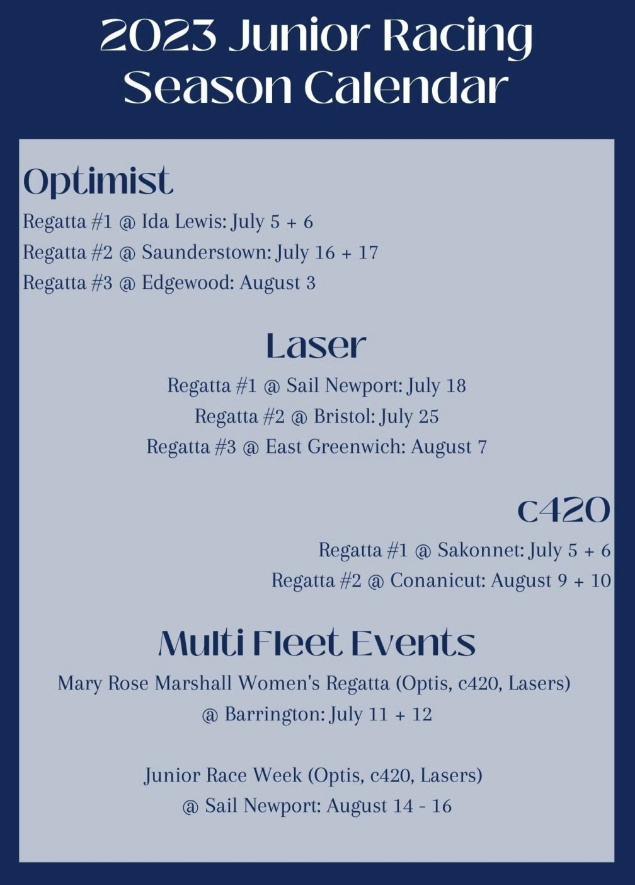
VOLUNTEER:
East Bay Sailing Foundation relies on the participation and enthusiasm of sailors, parents and guardians, grandparents, and friends.
There are plenty of opportunities to volunteer with the foundation, such as driving trailers, boat maintenance, communication and development. If you would like to volunteer please contact the program director for more information.
IN CASE OF EMERGENCY:
In the unlikely event that your child has a medical emergency, immediate action will be taken to assure their safety. The student will be assessed and either treated onsite or taken to the nearest medical facility. You will be contacted using the emergency contact information you provided during registration.
INCLEMENT WEATHER:
Safety is our number one priority and because we don’t have any indoor space we can’t operate during lightning storms. If inclement weather conditions are forecasted we may cancel the class by sending out an email the night before. We will run scheduled classes in light rain and we have many fun learning activites on shore for days that have some time onshore.
CODE OF CONDUCT:
East Bay Sailing foundation strives to provide a fun and safe environment in which to educate the next generation about the skills and joys of sailing. In order to do so it is of the utmost importance that we maintain a physically and emotionally safe educational environment. In order to do so the students must conduct themselves accordingly:
Students….
- Will respect their instructors, adults, BYC members, and fellow sailors.
- Will listen to the directions given to them by an instructor.
- Will treat EBSF equipment as though it were their own.
- Will display good sportsmanship at all times.
- Will not act in a way that endangers themselves or others. Safety first.
- Will conduct themselves in a manner that reflects positively on both themselves and EBSF
- Will not use cell phones or other electronic devices during class

CELL PHONE USE & ACCESS:
We ask that you discuss cell phone use with your child in advance of summer classes. We don’t want sailors on their phones unless it is for emergency use or to call for a ride home in case of inclement weather. All cell phones that come to class must be stored in the student’s bag in the EBSF storage area. Phones that are found in use without permission from a staff member will be held until the end of the day. Multiple offenses will require that the student turn over the phone to a staff member ashore each morning.
USE OF EQUIPMENT:
If a child is using a club boat any damage or loss of equipment that exceeds normal wear and tear (staff discretion) will be reported to the EBSF program director. At that point the cost of repair may be charged to the family. If damage is done to a double handed boat, the boat responsibility will fall on both the skipper and crew. EBSF is not responsible for damages done to privately owned or charter boats/equipment.
GUESTS AT BRISTOL YACHT CLUB:
We are very fortunate to be located at Bristol Yacht Club and wish to continue the positive relationship we have built over the years. We ask that your sailor respect and follow these guidelines. Sailing school participants are required to follow the BYC house rules.
BYC GENERAL SAFETY
All EBSF staff and students must follow the directions of the launch driver at all times. EBSF students must wear a life jacket at all time on the launches. Use the launch boarding ladder to board and disembark from all boats.
- EBSF staff and students must wear PFD’s when on EBSF boats or BYC docks/floats/boats.
- No Running on docks or floats. Appropriate footwear must be worn on docks/floats/boats.
- No recreational swimming off the dock, floats or boats tied to the floats.
CLUBHOUSE:
Access by EBSF staff to the EBSF office should be via the outside stairs through the doors on the Upper Deck. The upstairs Members’ Lounge is not intended for EBSF staff use.
- Shoes and shirts must be worn in the Clubhouse at all times. Wet clothing and shoes may not be worn in the Clubhouse.
- No EBSF staff or student shall use the Chart Room (bar) during EBSF programming hours. No one under legal drinking age will be permitted in the Chart Room at any time the bar is open. No one under the legal drinking age may consume alcoholic beverages on Club property at any time. No outside alcoholic beverages are to be consumed on Club property.
- EBSF staff and students are to use the outside heads; Clubhouse bathrooms are for use by BYC members and staff.
- Smoking in the clubhouse and anywhere on the BYC property is not permitted except in a designated smoking area in the west side parking lot.
- No unleashed pets are permitted on Club property. All owners are responsible for cleaning up after their pets. No pets are permitted in the Clubhouse except for certified service animals, whose presence should be brought to the attention of the Chief Steward.
EBSF teaching activities are conducted on the Lower Deck, Barbecue area and field. The two tables on the south side of the Lower Deck can be used by EBSF, leaving the other deck areas for use by members. EBSF Staff belongings (duffels, etc.) can be stored on the south end of the Lower Deck, leaving the doors and stairs clear of any items. The Upper Deck is reserved for use by BYC members and their guests. All chairs and tables must be put back as they were found if EBSF staff and students are not using them.

- Junior sailors are permitted on the south side of the lower deck. Clubhouse can only be used by arrangement during periods of formal instruction or at the invitation of the sailing instructors.
- Outdoor restroom and showers are for the use by Junior sailors.
- Junior sailors will store their personal belongings only in the areas designated for sailing program use. No personal belongings will be stored on the deck.
PERSONAL PROPERTY:
- EBSF and BYC assume no responsibility for money, jewelry, valuables or other property left on the club premises. There is a lost and found; check with the EBSF Sailing Director or the BYC Club Steward for lost items.
- IMPORTANT: Please take notice of assigned parking for BYC staff and board members. PLEASE DO NOT pull into or park in the EXECUTIVE BOARD parking area near the playground even for a brief drop off.
Thank you. Richard Feeny, Chairman East Bay Sailing Foundation

